# HELM Basics

**Contents**

HELM Basics 1

Introduction to HEML: 2

HELM Definition: 2

Need of Helm: 2

Helm Installation and Configuration: 2

Helm 2 Vs Helm 3: 3

Helm Components: 4

Helm Charts: 6

Structure of chart directory: 8

Working with helm: 8

Customizing chart parameters: 11

Lifecycle Management with HELM: 13

Helm Chart Anatomy: 15

Writing own Helm charts: 15

Verification of charts: 19

Functions: 22

Pipelines: 24

Conditionals: 24

Setting a scope using with block: 26

Ranges: 28

Named Template: 29

Chart Hooks: 30

Packaging and Signing Charts: 34

Uploading Charts: 36

## Introduction to HEML:

### HELM Definition:

* Helm is called a package manager for kubernetes.
* It looks individual objects as a part of big package or as a group.
* Hence whenever we want to make some change we don’t tell helm about objects that we should touch instead we just tell it what package we want to act on.
* Based on package name helm knows which objects it should change and how even if there are hundreds of objects that belong to that particular package.

### Need of Helm:

* Simple kubernetes cluster used to host website has many components like deployment, PVC, PV, service, secrets etc.
* For each object we have separate yaml file.
* To make changes in any of object we need edit respective yaml file and need to recreate respective resource.
* This is to be done with at most cate as we should not implement unwanted objects.
* Kubernetes treat each object individually and doesn’t care about objects are part of big application.
* Helm work as package manager for kubernetes cluster.
* Helm look each object as a part of package. So to implement change we address package on which helm to work upon and helm knows what objects it has to change.
* We uses single command, helm install to install number of objects. Helm proceeds automatically to add each object and add every necessary object to kubernetes.
* In case of upgrade helm knows what individual objects need to change to make this happen.
* Helm keeps track of all the changes made to the app files. That allows us to rollback to the previous revision.
* We can uninstall app using single command as helm keeps track of objects.

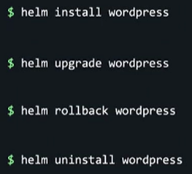

* **Helm treat our kubernetes apps as apps instead of just collection of objects and this takes a huge burden off our shoulders as we don’t have to micromanage each kubernetes object anymore.**

### Helm Installation and Configuration:

#### Documentation Link:

**https://helm.sh/docs/intro/install/#from-script**

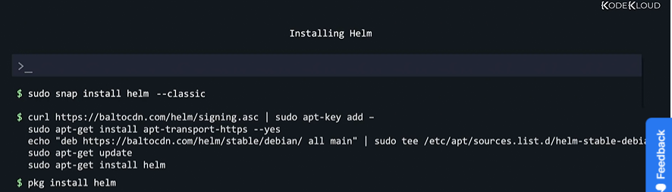

### Helm 2 Vs Helm 3:

* In helm 2 version middle agent called tiller is used to be install in kubernetes cluster so that helm can communicate with cluster and perform required operations.

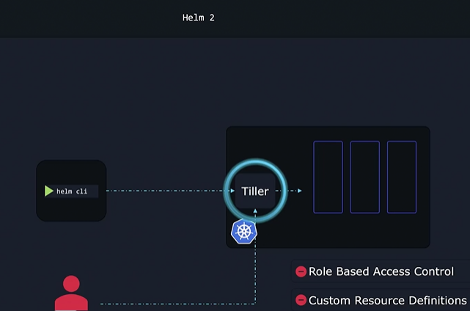

* Tiller can perform any operations in cluster and tiller has access to all users.

This is major concern for security of cluster.

* Additional features such as custom resource definitions and Role based Access Control need of tiller is suppressed in HELM 3.
* With RBAC we can limits operations performed by specific users.

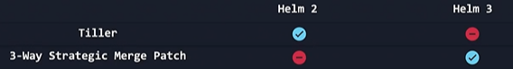

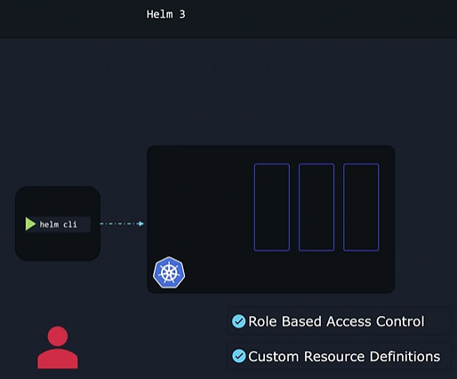

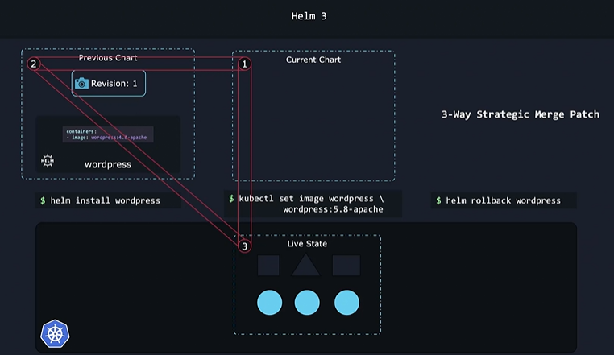

Helm 3 has record of current chart, previous chart and live state.

During upgrade or rollback Helm makes necessary changes to get into desired state and preserves this state.

### Helm Components:

* Charts is collection of files and they contains all instructions that helm needs to know to create required objects in kubernetes cluster.
* When chart is applied release is created. Release is single installation of an application using helm chart.
* Within each release you can have multiple revision and each revision is like snapshot of an application.
* With each change in any object new revision is created.
* Helm chart are available in pubic repo. We can easily download publicly available charts from pubic repo for various applications.
* To keep track of all metadata such as actions in cluster, revision state, chart data helm saves this data into kubernetes cluster in the form of secrets. This way the survives as long as the kubernetes cluster survives and everyone from the team can access it.

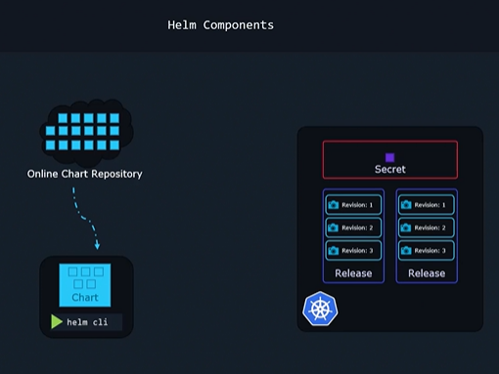

#### Charts yaml files:

* Instead of using hard coded values charts yaml files uses special syntax called templating values. With this syntax we assign values from another file called values.yaml

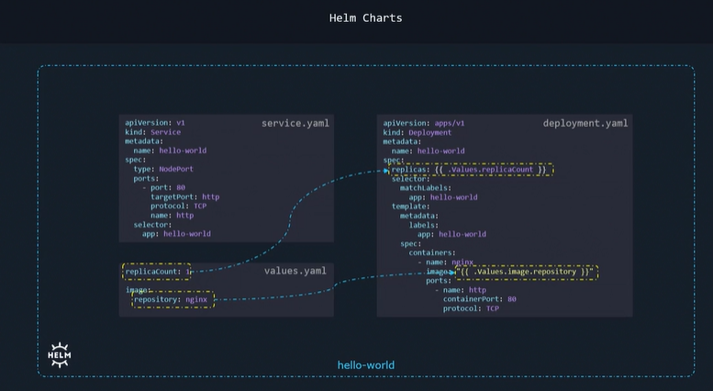

* To change the values we need to make changes only in values.yaml file.

#### Helm Release:

* We can install multiple release based on the same chart and we can track and make changes to theme separately based on name as they entirely different entities.

One of use case of release is that one release can be used at development site and other one at production.

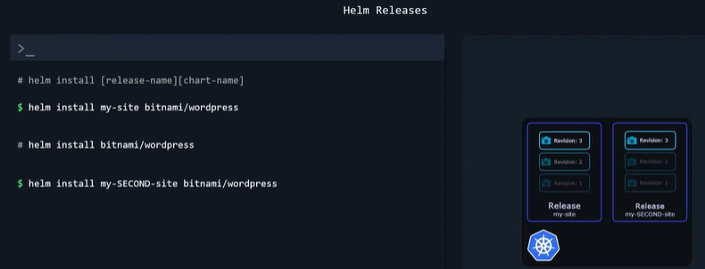

#### Helm Repositories:

* Thousands of charts are readily available at different Helm repositories. There are different providers hosting repositories of helm charts such as Appscode, Truecharts, Bitnani etc.

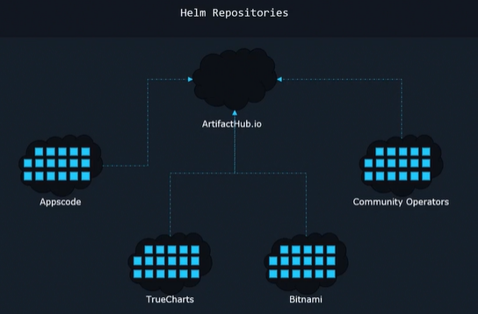

* All providers are listed at single location called Helm Hub or Artifact Hub at artifacthub.io

### Helm Charts:

* Helm use charts to complete its allocated work.
* Helm reads and interpret the contents of charts.
* Charts are bunch of files and each specific files named in specific way has well defined purpose.
* Values to parameters of charts.yaml file can be assigned from values.yaml file using method called templating.
* Each chart also has chart.yaml file. It contains information about Chat apiversion (v1 or v2 for heml3), app version, name of chart, description of chart etc.

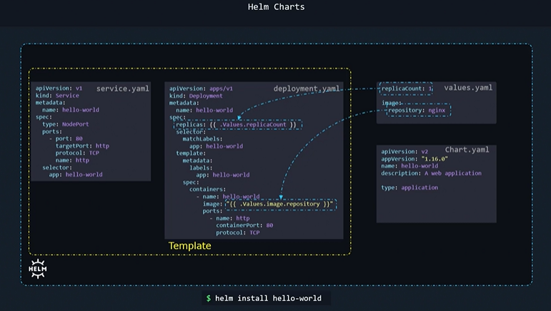

#### Fields of chart.yaml file:

* apiVersion: v2 incase od helm 3 and v1 but optional in case of helm2.
* appVersion: version of application. Used for information purpose only.
* version: version of chart itself. It helps to track changes of chart itself.
* name: It is name of chart and generally it is application name.
* description: provides information about chart.
* type: It is type of chart:

Chart is of two types: application and library.

application: It is default chart type and used to deploy application.

library: it is type of chart provides utilities that help to create chart.

* dependencies: for multitier application dependencies can be mentioned using this field.
* keywords: list of keywords associated with this project. It is helpful to search chart in pubic repo.
* home: url of homepage
* icon: url of icon

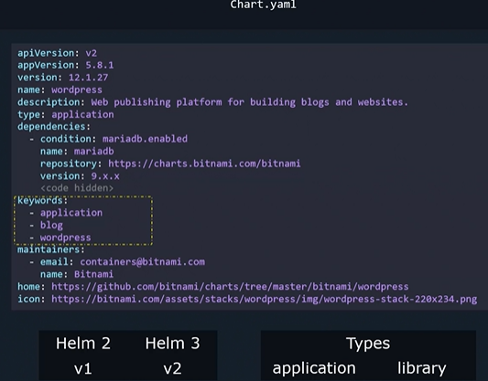

### Structure of chart directory:

* templates: has template files such as values.yaml, Chart.yaml, LICENSE file, ReadMe file
* Charts directory may be there if there are other charts on which this chart is depend on.

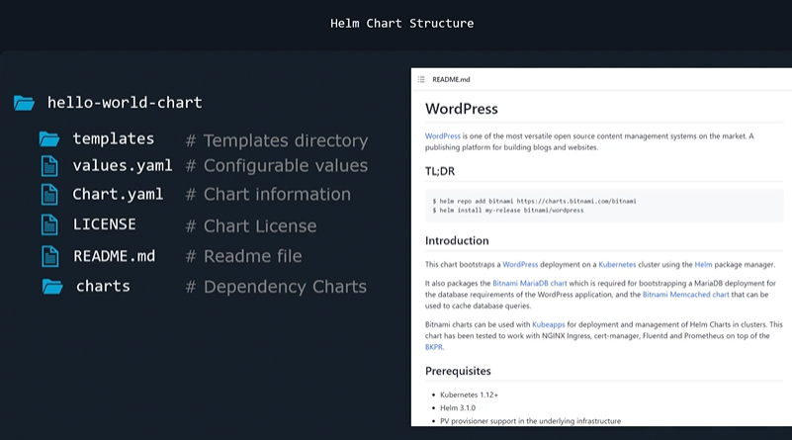

### Working with helm:

* To invoke helm CLI use simple helm command.

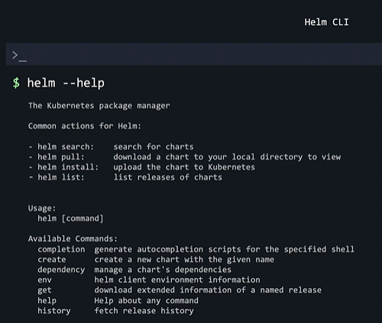

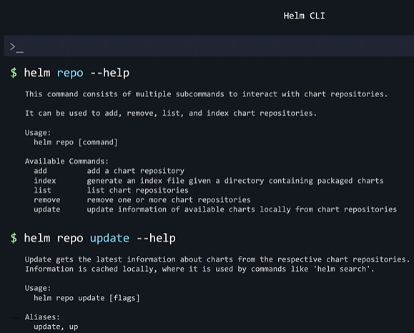

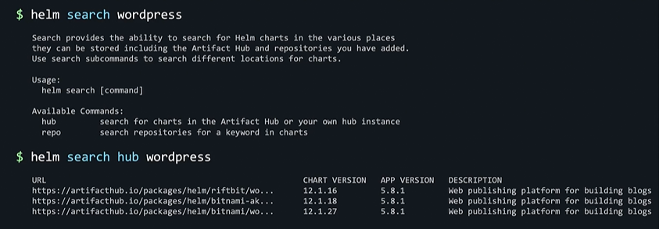

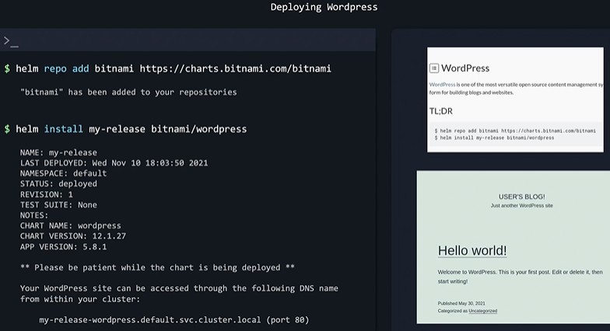

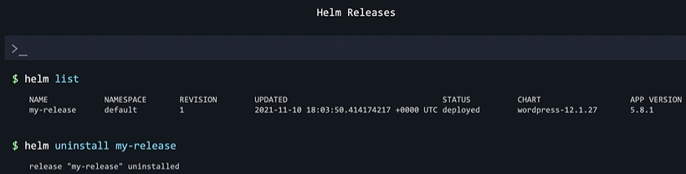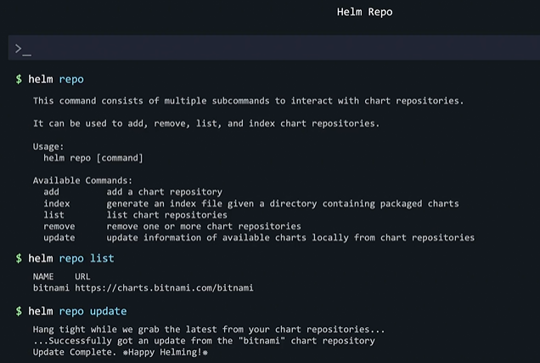

### Customizing chart parameters:

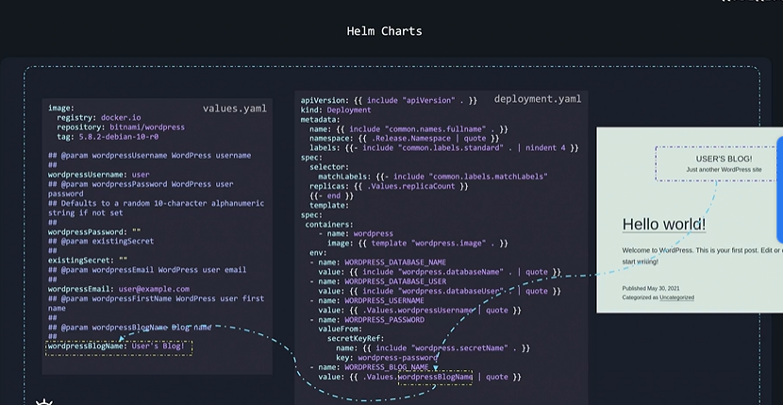

* Helm install command pulls charts and installs it immediately. Hence there is no scope for editing default chart parameters.
* We can set default values of chart parameters of values.yaml file over command line using --set option.
* This overrides the values set in values.yaml file.

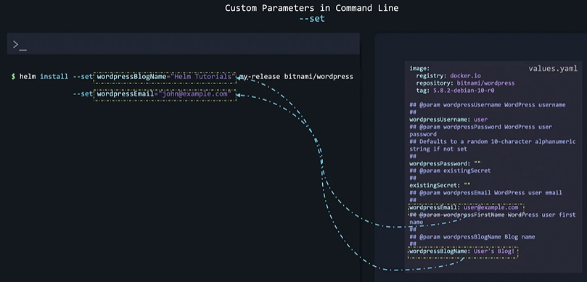

* If there are too many such values to be changed we can define theme in custome-values.yaml file and use --values option as follows.

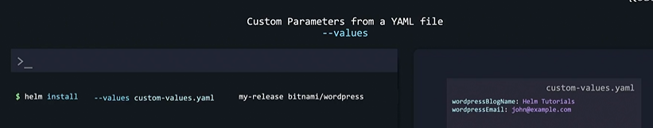

* To modify values of values.yaml file we can pull charts first and then modify theme. Charts are pulled in an archived or compressed form. We need to un-compress or unarchive it using --untar option. After modification we can upload it on repository and install it or install it using charts available in local filesystem.

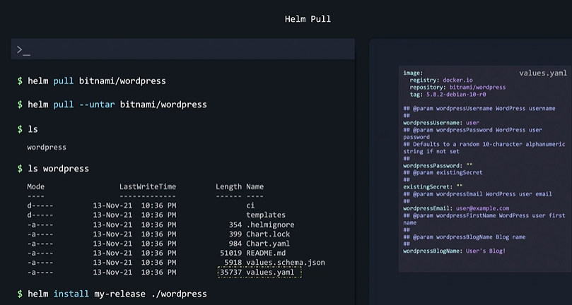

### Lifecycle Management with HELM:

* Each time we pull chart and install chart new release is created.
* Helm knows objects belong to release it can manage theme for upgrade, degrade, uninstall without touching objects of other release.
* Each release is managed independently even they created using same chart.

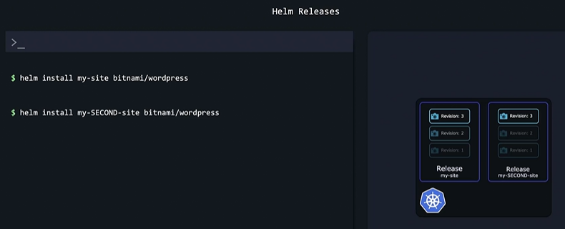

* We can use specific chart version to create release using --version option.

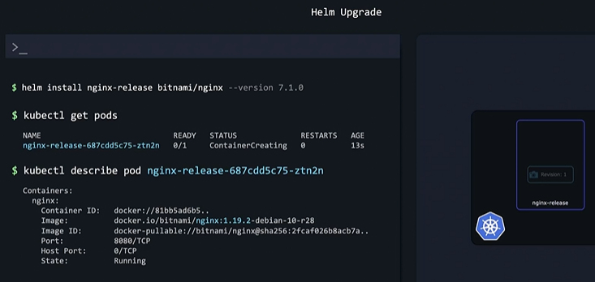

* We can upgrade release to desired version. With upgrade process new revision is created and current revision replaced with new revision.

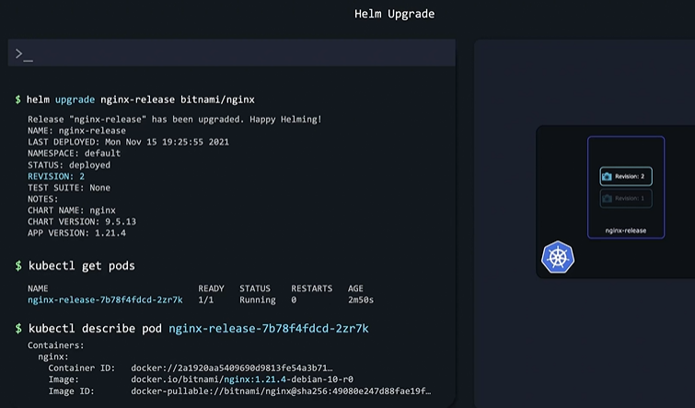

* Helm keeps track of current stage, previous stage, and future stage. During upgrade process helm try to achieve desired future state and along with also maintains history of changes by assigning revisions number.
* We can list, view historical data and perform rollback in case of undesired events during upgrade.

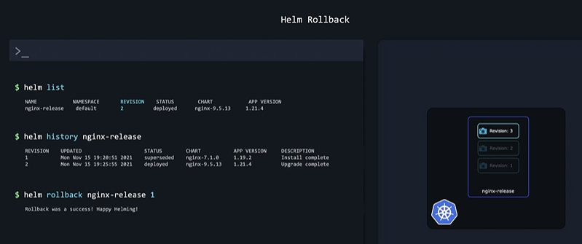

* Sometimes we need administrative access using passwords to certain resources during upgrade process.
* HELM only back up applications by storing declarations and manifest files but not the data created by applications such as file, external database etc. Hence rollback can’t restore that external data.
* There are options available to take consistent back up of external databases etc. before upgrade or changing anything using chart hooks.

## Helm Chart Anatomy:

### Writing own Helm charts:

* Whenever we do helm upgrade a database can be automatically backed up and we can restore it if something wrong happens.

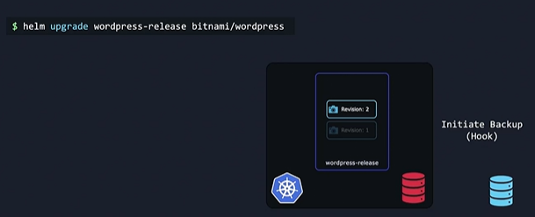

* Helm create command creates skeleton structure of directory. It create templates subdirectory and required other files.

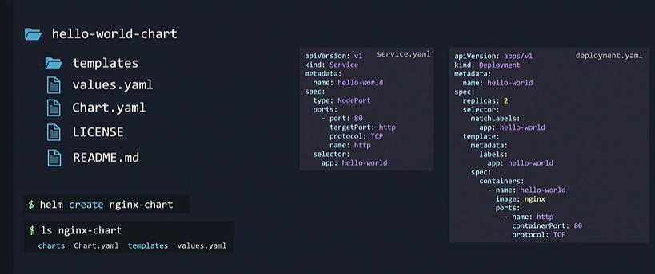

* templates subdirectory has another subdirectory called tests having some sample files of general resources like deployment, services, ingress, service, service account etc.

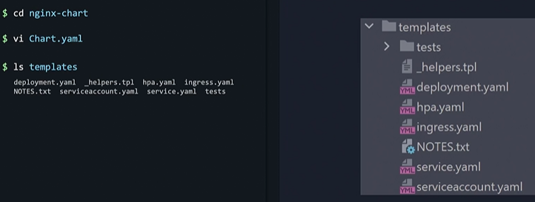

* We can’t assign static name to resources. For each release we need to assign different names to resources. To achieve this we assign values of required parameters using templates (assigning name of resources in combination with release name automatically).
* For this helm uses syntax of Go Programming Template Language.
* As per syntax we define path to object within curly braces. Path starts with . ( refers to root level or top level scope).

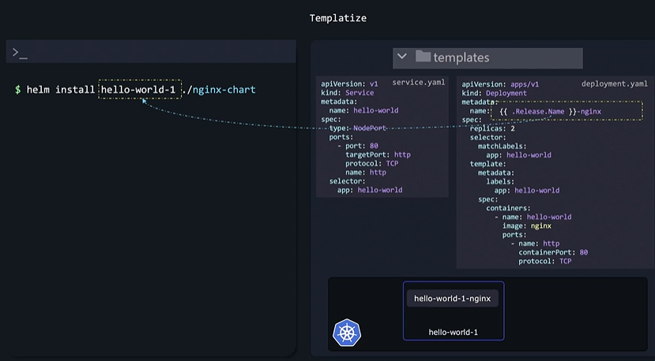

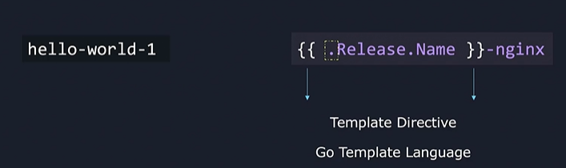

* Similar to release name there are other objects listed below.
* First and second part of . starts with capital letters for Release, Chart, Capabilities objects. Where as in case valise we have to use object name as it is because second part of values object is case sensitive. Values object refers to values.yaml file.

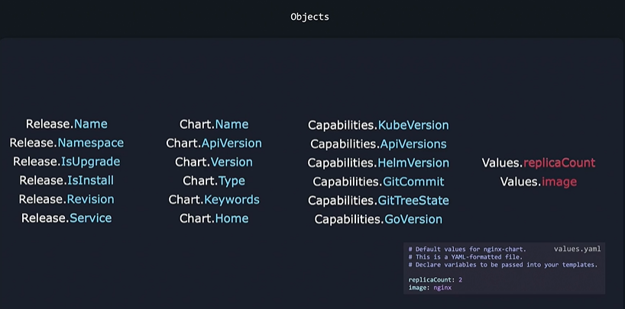

* Helm do not allow to use same release name. Hence templatizing resource names using release object helps to assign unique name to resources. Helm can manage theme separately based on release.

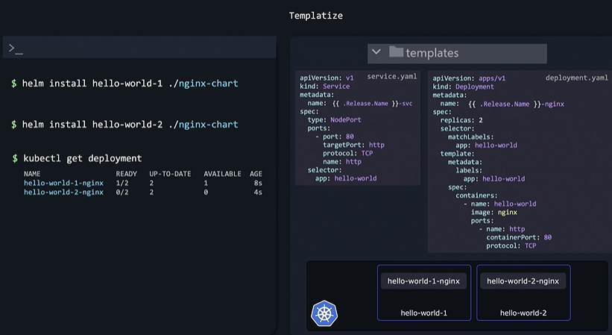

* Values templatize using values object can be pass using ---set option or we need to define theme in values.yaml file.

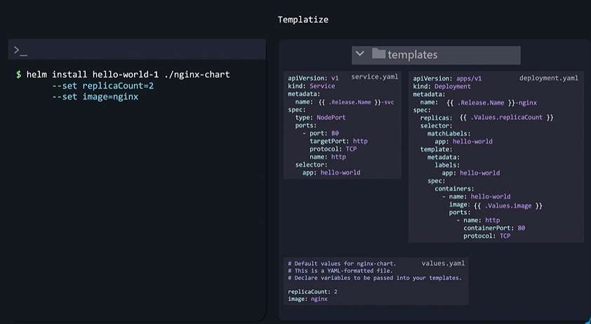

* We can combine object template values to get desired names.

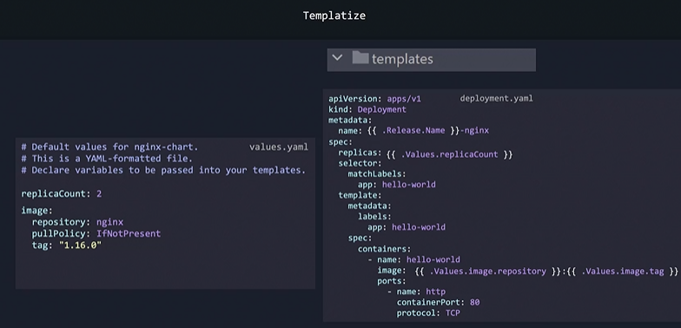

* So final yaml file of resources is combination of template file, values.yaml file, release details, chart details.

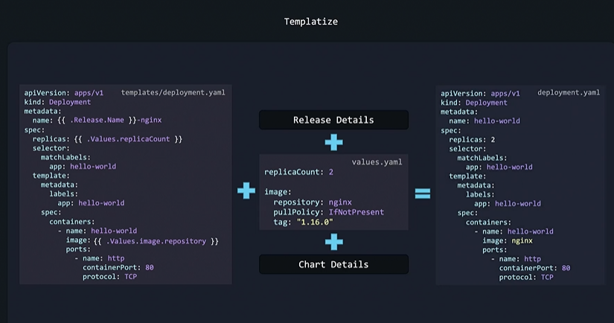

### Verification of charts:

**Charts can be verified using 3 methods:**

#### Lint:

* Option used to verify correctness of chart and its yaml format.

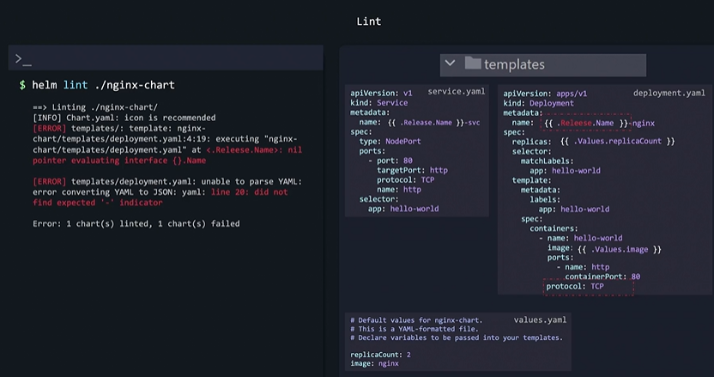

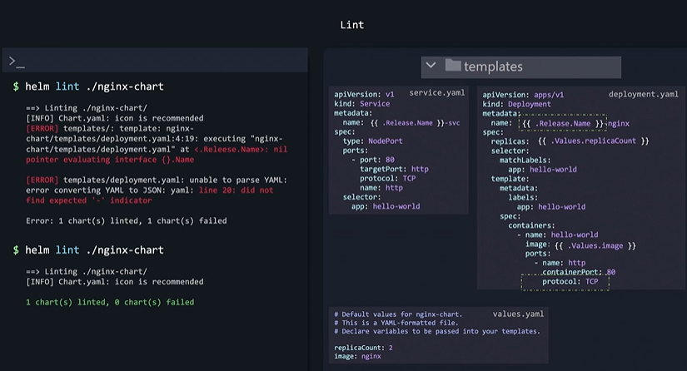

#### Template:

* Option used to check whether templating part works as expected.
* If we use template option without release name it will show RELEASE-NAME in the output.

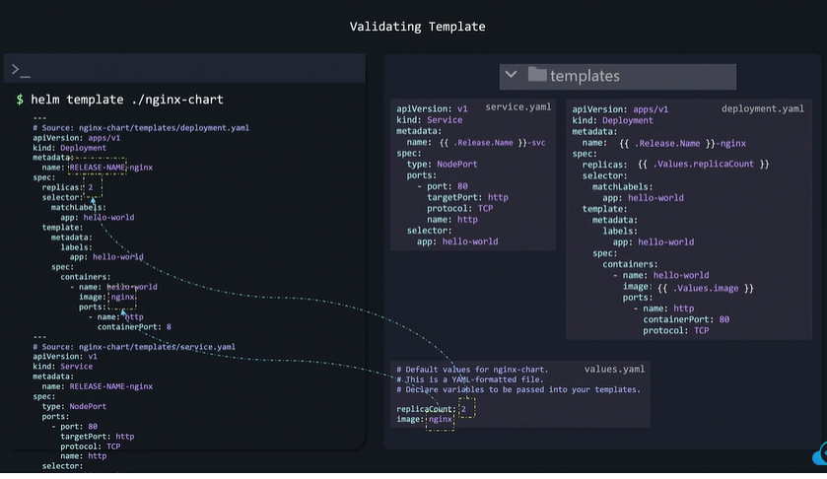

* If we use template option with release name e.g. hello-world-1 it will show hellow-worls-1 in the output.

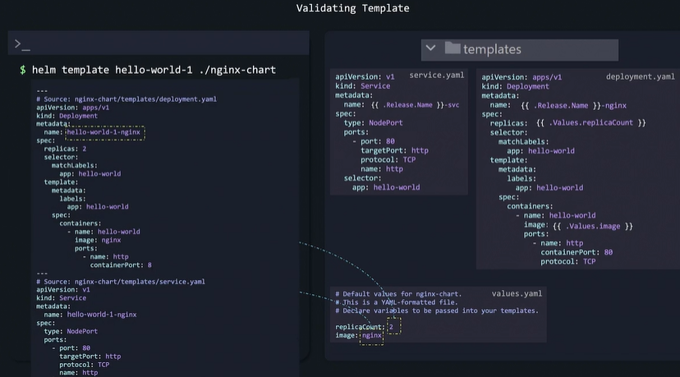

* In case of wrong indentation yaml file will not show proper output with template option. With given output we can’t spot the indentation error for rectification.
* We use --debug option along with to spot the indentation error as follows.

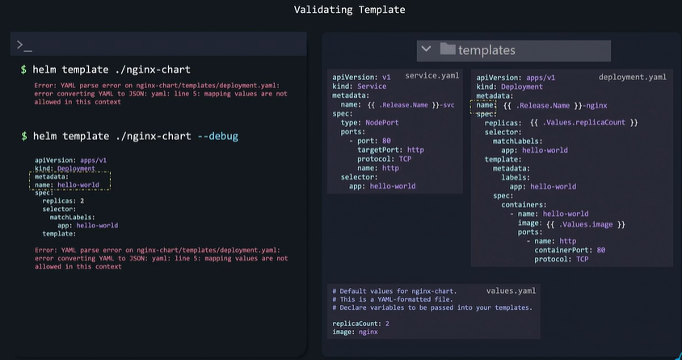

#### Dry run:

* Option used to make sure that charts work well with kubernetes itself. Sime of error can’t be identified with lint or template otion. We can use --dry-run flag along with helm install command to identify such errors.
* If there are some errors output of command will display errors.
* If there is no errors output of command will display actual yaml files in the final format.

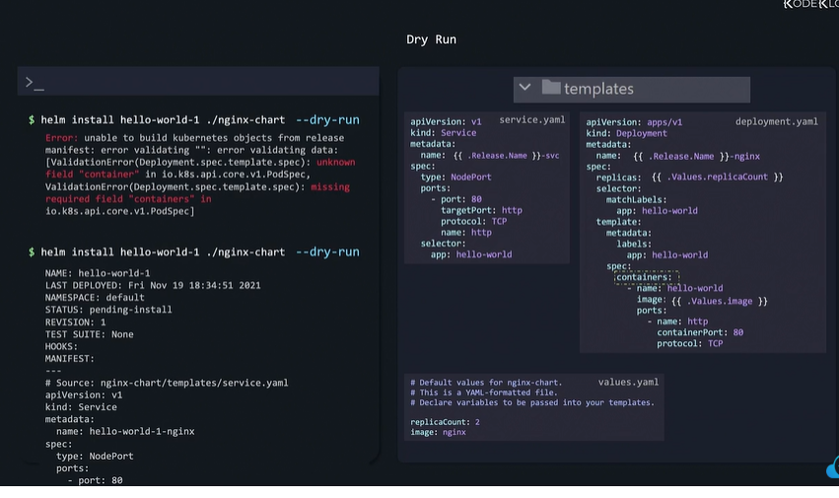

### Functions:

* Functions are used to modify behavior or format of templating values used in helm charts.
* Various type of functions are listed below.

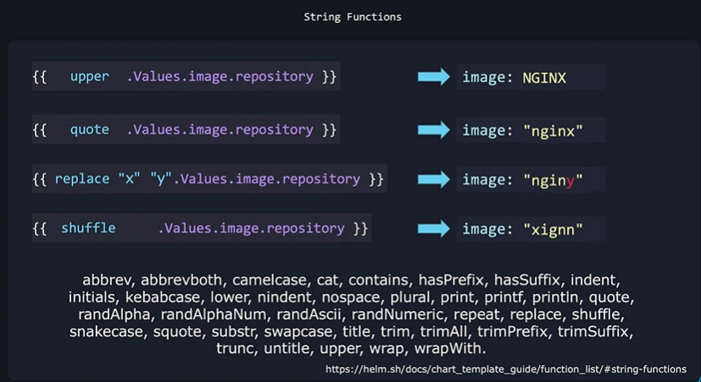

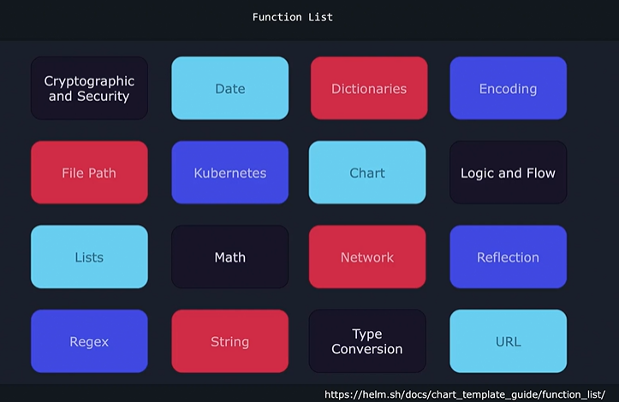

* One of function is default function which provide default value to parameter if user is not provided or result of templating value is blank.

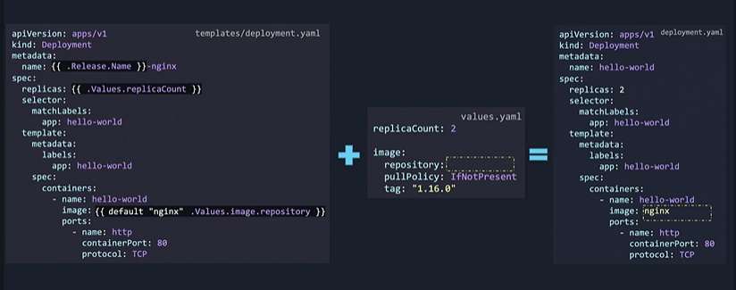

### Pipelines:

* We can also use functions using pipe symbol as follows.



* We can combine effect of multiple functions using pipe symbol.





### Conditionals:

* Some times during templating we need to assign values based on certain conditions.
* For such requirement if block is used as follows.

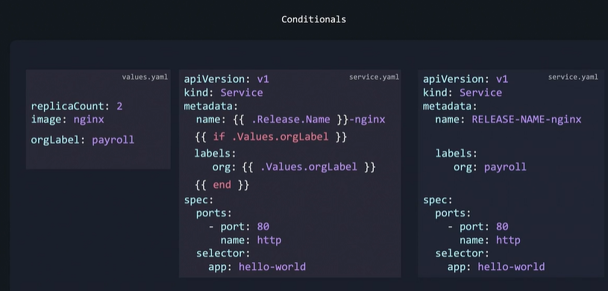

* If value is not assigned to given parameter in values.yaml file it will be resulted into final yaml file as follows.

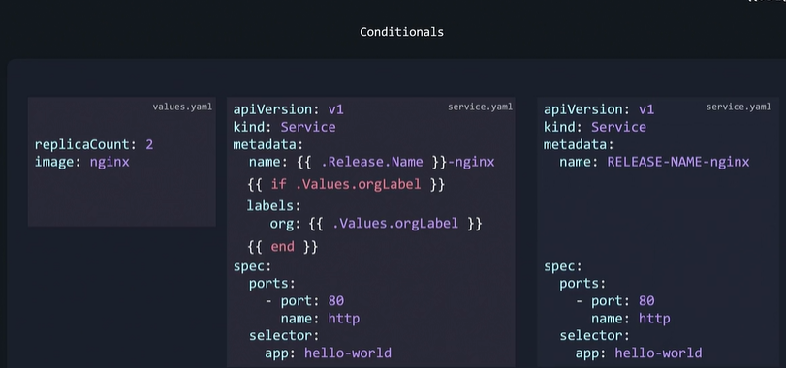

* But adding if block in such way add empty lines in final yaml file. To avoid it – is used at start of if block.

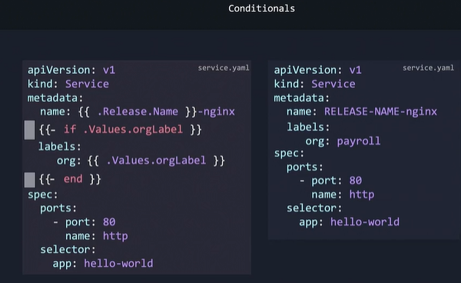

* We can add more conditions using else if block as follows. We can use functions listed below for comparison.

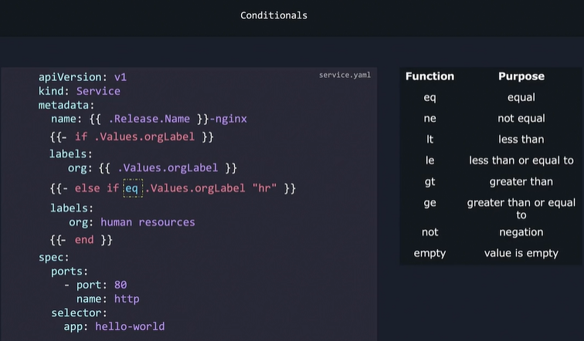

* One more example of conditional block.

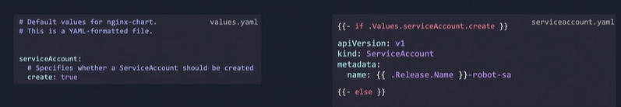

### Setting a variable scope using with block:

* Example to understand scope:

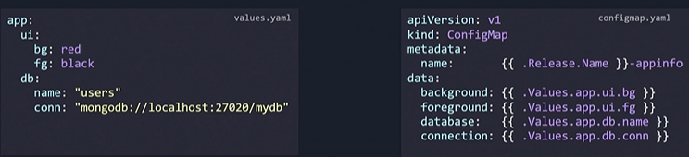

* Scope Hierarchy of parameters for above e.g.

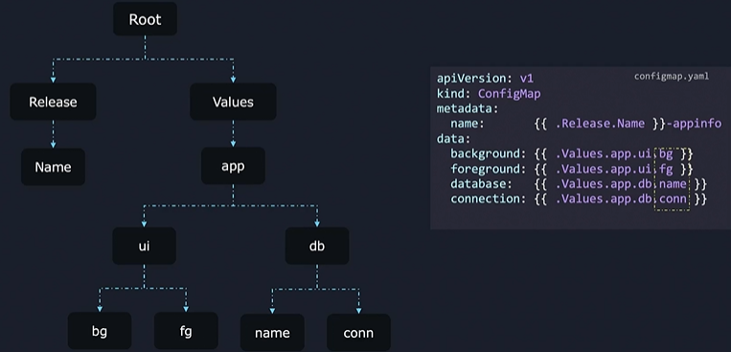

* If scope is not defined then current scope is root by default. Hence for templating we have to give entire path of parameter. This adds repetition in helm chart yaml files.
* But if we define scope we can avoid repetitive code in yaml files as follows.

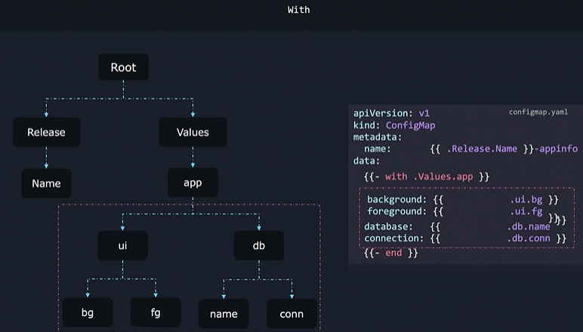

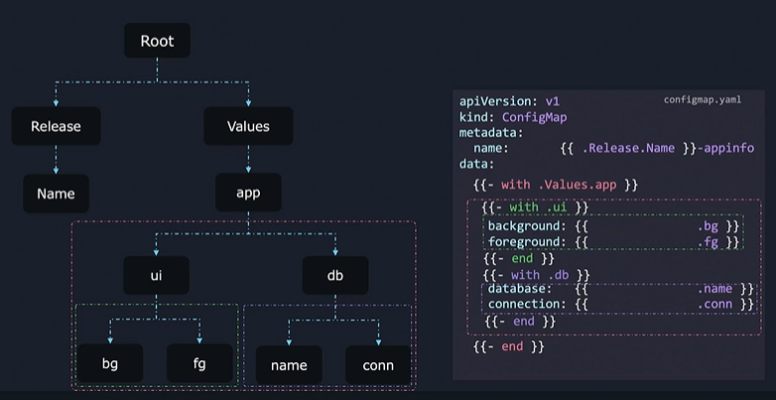

* Inside with block we can use $ symbol to represent root scope.

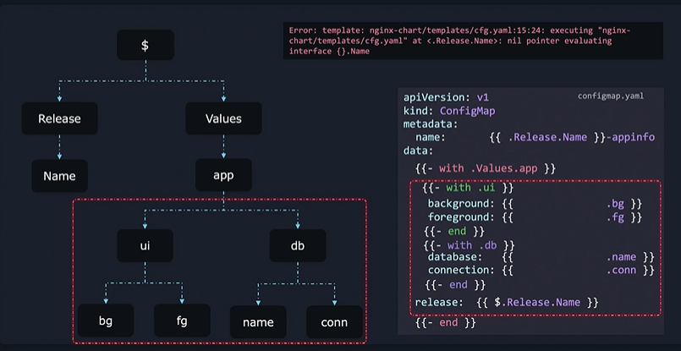

### Ranges:

* We can use range function as a loop to do repetitive work.

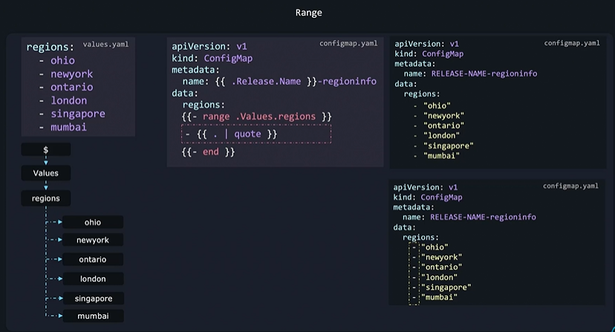

### Named Template:

* Partial or Named Templates are used to remove repeating lines from yaml file of resources.
* Named template filename start with _. During resource or object creation Helm skip such files.
* Named template file has extension .tpl
* Template file do not have scope. If any of parameters of template file to be retrieved by templating it will not able to do so. To add scope we need to provide extra dot wherever we are using template file reference in resource file.
* This way contents of template file will be added to resource or object file.

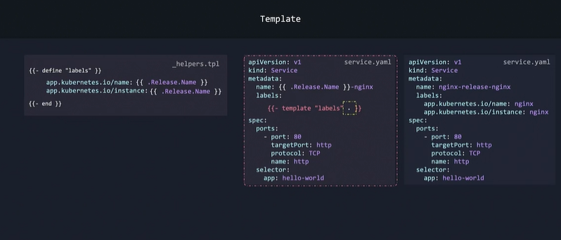

* Contents will be added to same indentation level as we define.
* But this will not be useful if contents are to be added at different indentation level.

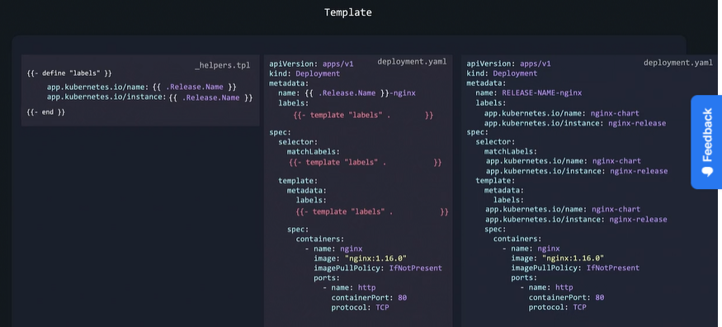

* To solve indentation problem we use indent function. But template is not a function. So we can’t pipe its output to indent function. To resolve this we use include function instead of template wherever we require additional indentation.

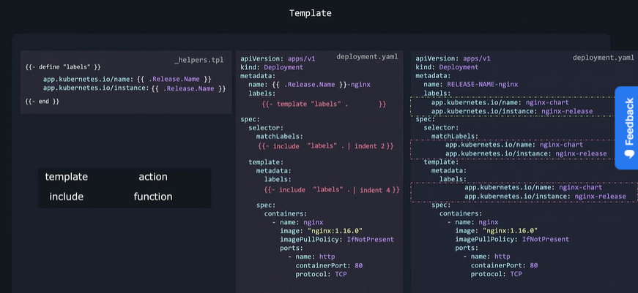

### Chart Hooks:

* Extra action which are not part of kubernetes resource management such as backup of database is performed using hooks during Help Operations.

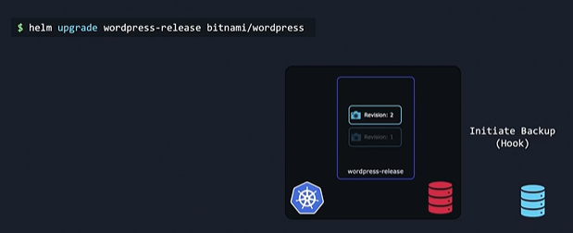

* Following is the flow of upgrade or installation during Helm Upgrade.

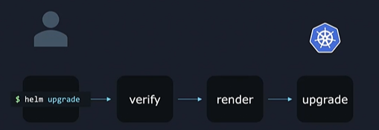

* To fulfill the requirement of database upgrade we can insert pre-upgrade hook in above flow.
* Pre-upgrade hook is predefined action which can be anything in our case backup of database.

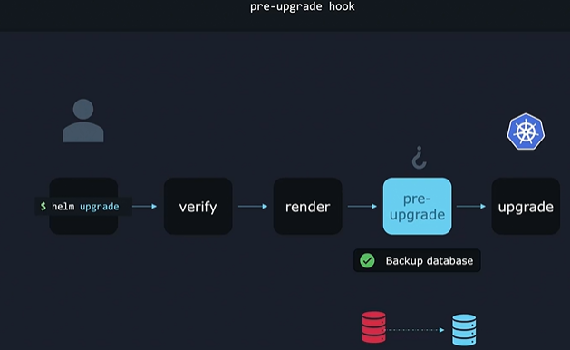

* We may require to perform some action like clean or sending email communication post upgrade activity. This can be implemented using post upgrade hook.

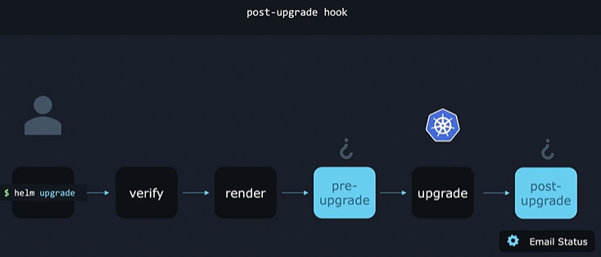

* There are various type of hooks based on operation to be performed by Helm.

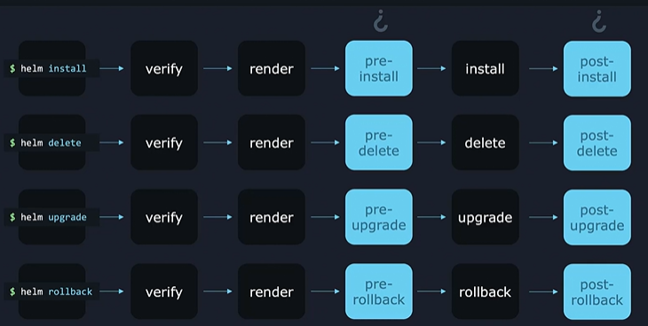

* Actions to be performed under hooks are onetime actions hence Hooks are created as a job object.
* Hooks are defined as a job object in yaml format but to differentiate it with normal object definition file we need to add annotation in yaml file as shown.

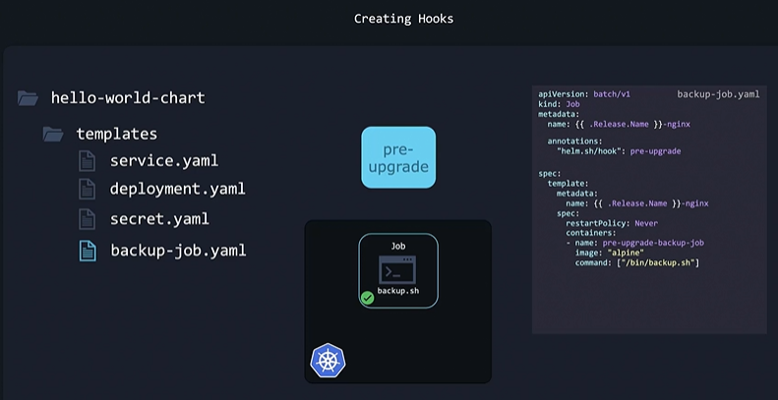

* We can configure multiple hooks for multiple activities and assign a weightage to theme do decide sequence in which they should execute.
* Weightage can be negative or positive number. Hook with Lowest will be executed first.
* Hooks with equal weightage will be sorted based on kind and then by name and executed in the order in which they are sorted.

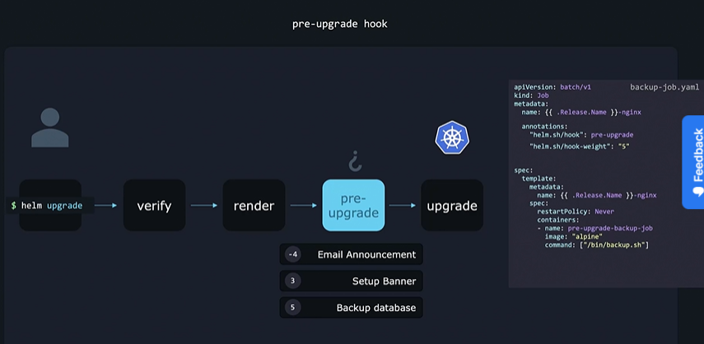

* After execution hook resource will be available with completed state and it will stay as a resource on cluster. We can configure theme to be cleaned up by setting up hook deletion policies.
* To do this we have to add annotation hook-deletion-policy and set the supported value like hook-succeeded. This is helpful if hook failed created resource won’t be deleted and can be used for troubleshoot.
* Another supported value is hook-failed which deletes hook resource in case of failure of hook execution.
* If hook deletion policy is not mentioned then it is set to default value i.e. before-hook-creation. This deletes old resource before new hook is launched.
* With this old hook resource will persist and kept hanging around until next upgrade cycle. Th pre-upgrade hook will delete the old kubernetes hook object and create new one which will persist until next upgrade cycle and so on.
* This helps to avoid duplicate object creation with same name. So that kubernetes will not complain with error message.

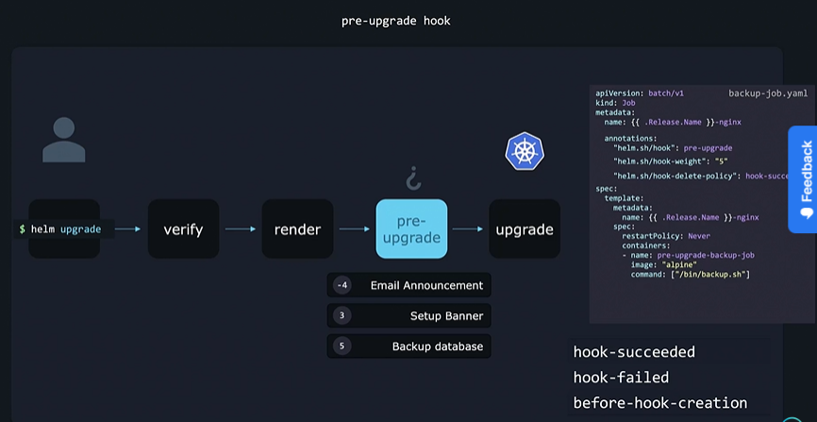

### Packaging and Signing Charts:

* To make package form chart files we need to use helm package command.
* Package is stored in .tgz archive format. Version of the package is derived from Charts.yaml file.

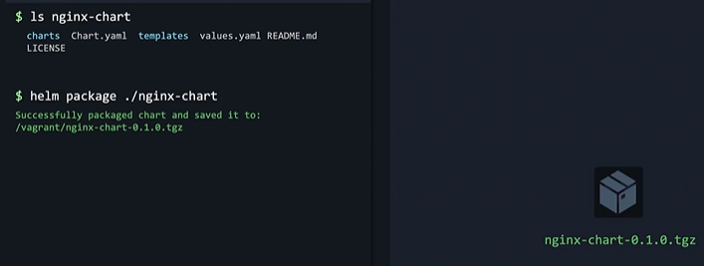

* But this is not recommended to upload this file as it is for security reasons.
* To secure process of uploading and downloading we need sign files and packages cryptographically.
* Helm provide necessary tools to do this. Helm uses private key that developers of charts have access to. New digitally signed file called provenance file is created using this key.
* Users can download charts and provenance file and verify it using public key.
* We can generate public private key using GNU privacy guard or gpg utility which is included in most of linux distributions.

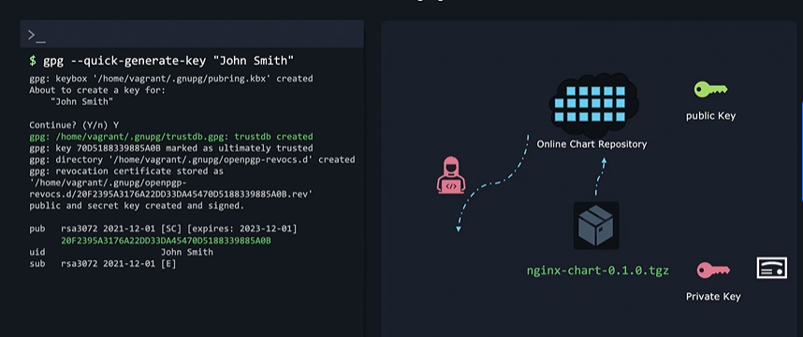

* The unique identifier shown in pub section of the output of above command is public key. This can be uploaded to open PGP key server like keyserver.ubuntu.com etc.

Users can download it and verify our signature.

* For production server it is created using following options. This will ask more details like password, email id, expiration date etc.

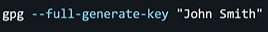

* Now days linux distributions uses advance format whereas Helm used old format of key-pairs. To convert keys of new format to old format use following command and output is saved in ~/.gnupg/secring.png file.

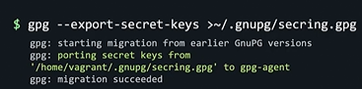

* Now we can package charts with key as follows.

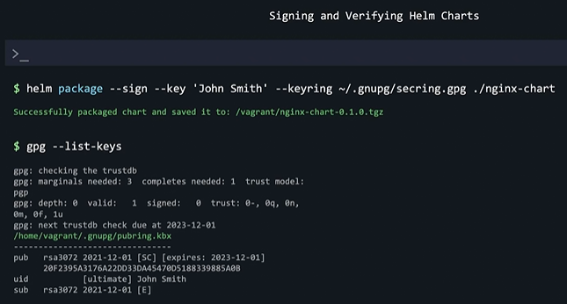

* User can verify integrity of chart with helm verify command. For gpg version 2 we need to convert it into old format using export command and then verify the signature.

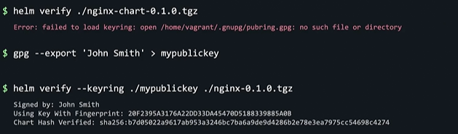

* In real scenario user will download pubic key first and then can use helm verify command.
* We can use --verify command to along with install command to ensure that we are not installinh start that we can’t trust.

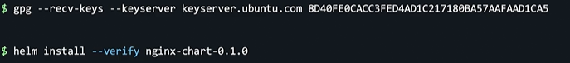

### Uploading Charts:

* Helm packages are required to be uploaded online so that those can be shared with other users.
* Chart repository consist of mainly 3 file packaged charts with .tgz extension, index.yaml file and provenance file.
* Index file: contains info about chart repository, checksum for .tgz file etc. This file is read when we add new repository.
* Provenance file: used to verify cryptographic signatures. These are used to ensure user that they are downloading contents approved by us and not some potentially malicious contents that attacker could have uploaded over compromised server.

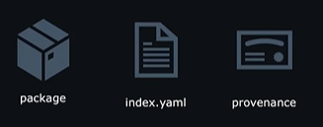

#### Steps to create index.yaml file:

* Create a new directory and add required files i.e. .tgz and .prov files to this new directory.
* Use helm repo index command as shown. We need to provide repo url with --url option.

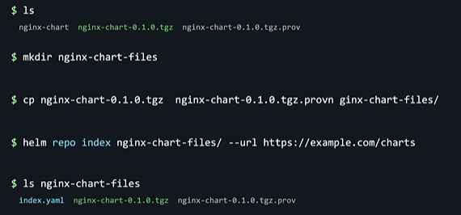

* index.yaml field consist of following fields.

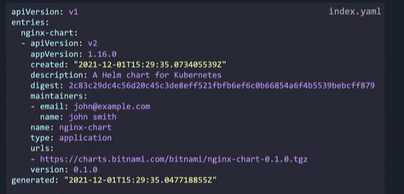

* With this our package is ready for upload and we can upload it to remote repos.
* We can share url of locations where we have uploaded package file to other users so that they can download with helm process.

